**([**

**{ Name: "Ananya", ID: 101, Age: 20, Mark: 85, Grade: "B" },**

**{ Name: "Raj", ID: 102, Age: 22, Mark: 90, Grade: "A" },**

**{ Name: "Priya", ID: 103, Age: 19, Mark: 75, Grade: "C" },**

**{ Name: "Vikram", ID: 104, Age: 21, Mark: 80, Grade: "B" },**

**{ Name: "Neha", ID: 105, Age: 23, Mark: 95, Grade: "A" },**

**{ Name: "Aditya", ID: 106, Age: 24, Mark: 88, Grade: "B+" },**

**{ Name: "Sneha", ID: 107, Age: 20, Mark: 92, Grade: "A" },**

**{ Name: "Rohan", ID: 108, Age: 21, Mark: 78, Grade: "C+" },**

**{ Name: "Kavita", ID: 109, Age: 22, Mark: 81, Grade: "B" },**

**{ Name: "Amit", ID: 110, Age: 23, Mark: 89, Grade: "B+" }**

**]);**

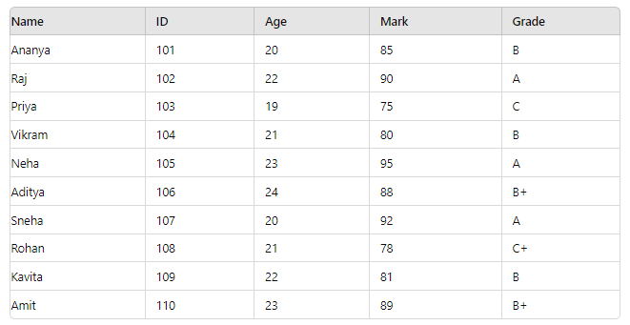

Convert SQL statement into MONGODB  query

1. CREATE TABLE Students ( Name VARCHAR(50), ID INT PRIMARY KEY, Age INT, Mark INT, Grade CHAR(2) );
2. SELECT * FROM Students;
3. UPDATE Students SET Mark = 93, Grade = 'A' WHERE ID = 101;
4. DELETE FROM Students WHERE ID = 103;
5. SELECT * FROM Students WHERE Age > 20 AND Grade = 'A';
6. SELECT * FROM Students WHERE Grade = 'A' OR Grade = 'B+';
7. SELECT * FROM Students WHERE (Age < 21 AND Mark > 80) OR (Grade = 'A' AND NOT (Age = 22));
8. SELECT * FROM Students WHERE Name REGEXP '^A';
9. SELECT * FROM Students WHERE Name REGEXP 'vi';
10. SELECT * FROM Students WHERE Name REGEXP '^.{5}$';